

BANGABANDHU SHEIKH MUJIBUR RAHMAN DIGITAL UNIVERSITY,

BANGLADESH

# Department of Internet of Things and Robotics Engineering.

**Faculty of Cyber Physical System**

**Lab Report-04**

## Study and Observation of Clipper Circuit

## Submitted by:

**Group - 05**

**Mehrin Farzana (2101013) Maria Jahan Mim (2101022) Ismot Ara (2101027)**

**Sadia Islam Mou (2101028)**

**Submitted to:**

**Sadia Enam Lecturer, Department of IRE**

**Bangabandhu Sheikh Mujibur Rahman Digital University, Bangladesh.**

**Date of Submission: 12 February,2024**

**CONTENTS:**

1. Experiment no. 02,07
2. Experiment Name. 02,07
3. Objective......................................................................................(2-3),(7-8)
4. Theory.......................................................................................…………03,08
5. Required apparatus. 03,08
6. Circuit Diagram. 04,09
7. Output. ……..05,10
8. Discussion. 06,11

# Experiment no: 01

1. **Experiment Name:**

Designing a clipper circuit with a negative reference voltage.

# Objective:

## Understanding Clipper Circuit:

* Explore the concept of AC voltage signal clipping.
* Investigate how a Diode contributes to signal clipping.

## Analysis of Circuit Components:

* Identify and understand the components of a clipper circuit, including diodes.
* Examine the role of each component in the clipping process.

## Measurement and Calculation:

* Measure and record the input and output voltages at various points in the circuit.
* Calculate the ripple factor and efficiency of the circuit.

## Waveform Analysis:

* Observe and analyze the input and output waveforms using an oscillo- scope.
* Compare and contrast the input and output waveforms to understand the clipping process.

## Efficiency and Ripple Factor Calculation:

* Determine the efficiency of the circuit by comparing the output power to the AC input power.
* Calculate the ripple factor to evaluate the smoothness of the clipped output.

## Effects of Load Resistance:

* Investigate the influence of load resistance on the performance of the full- wave rectifier.
* Analyze how changes in load resistance affect the output voltage and cur- rent.

## Comparison with Theory:

* Compare the experimental results with theoretical expectations based on the ideal characteristics of a full-wave rectifier.
* Identify any discrepancies and analyze possible sources of error.

# Theory:

A clipper circuit is an electronic circuit designed to "clip" or limit the voltage amplitude of an input signal. It is used to remove unwanted portions of the input signal. There are two types of clipper circuits: Negative clipper and Positive clipper.

# Required apparatus:

* Resistor
* Alternator
* Diode
* DC source
* Oscilloscope

# Circuit Diagram:

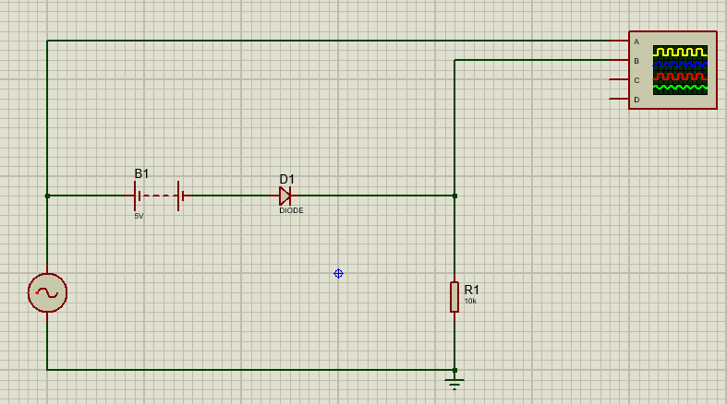

Figure 1: Circuit Diagram of Negative Clipper Circuit.

# Output:

Input Signal, Output Signal-

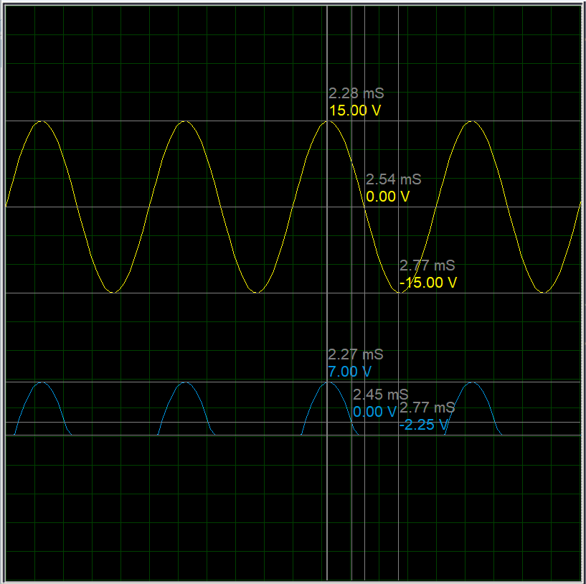

Figure 3: Input and output Signal for circuit in Figure 1.

# Discussion:

Here,

For positive half cycle,

Vinput < Vbias : Voutput = 0 V

Vinput > Vbias : Voutput = Vinput - Vbias

Here, Vbias = 5 V

|  |  |
| --- | --- |
| **Vinput** (in volt) | **Voutput** (in volt) |
| 15 | 10 |
| 0 | 0 |

Again,

For negative half cycle,

Vout = 0 V

Here, the numbers don’t exactly match the digits in the simulation due to voltage drop accross the diode as it is not an ideal diode

# Experiment no: 02

1. **Experiment Name:**

Designing a clipper circuit by reversing the diode in experiment 01.

# Objective:

## Understanding Clipper Circuit:

* Explore the concept of AC voltage signal clipping.
* Investigate how a Diode contributes to signal clipping.

## Analysis of Circuit Components:

* Identify and understand the components of a clipper circuit, including diodes.
* Examine the role of each component in the clipping process.

## Measurement and Calculation:

* Measure and record the input and output voltages at various points in the circuit.
* Calculate the ripple factor and efficiency of the circuit.

## Waveform Analysis:

* Observe and analyze the input and output waveforms using an oscillo- scope.
* Compare and contrast the input and output waveforms to understand the clipping process.

## Efficiency and Ripple Factor Calculation:

* Determine the efficiency of the circuit by comparing the output power to the AC input power.
* Calculate the ripple factor to evaluate the smoothness of the clipped output.

## Effects of Load Resistance:

* Investigate the influence of load resistance on the performance of the full- wave rectifier.
* Analyze how changes in load resistance affect the output voltage and cur- rent.

## Comparison with Theory:

* Compare the experimental results with theoretical expectations based on the ideal characteristics of a full-wave rectifier.
* Identify any discrepancies and analyze possible sources of error.

# Theory:

A clipper circuit is an electronic circuit designed to "clip" or limit the voltage amplitude of an input signal. It is used to remove unwanted portions of the input signal. There are two types of clipper circuits: Negative clipper and Positive clipper.

# Required apparatus:

* Diode
* Resistor
* Alternator
* DC source
* Oscilloscope

# Circuit Diagram:

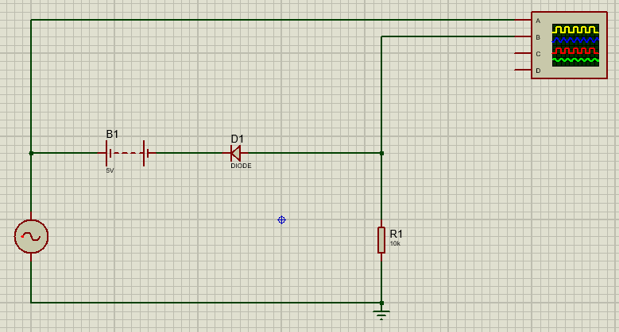

Figure 3: Circuit Diagram

# Output:

Input Signal, Output Signal-

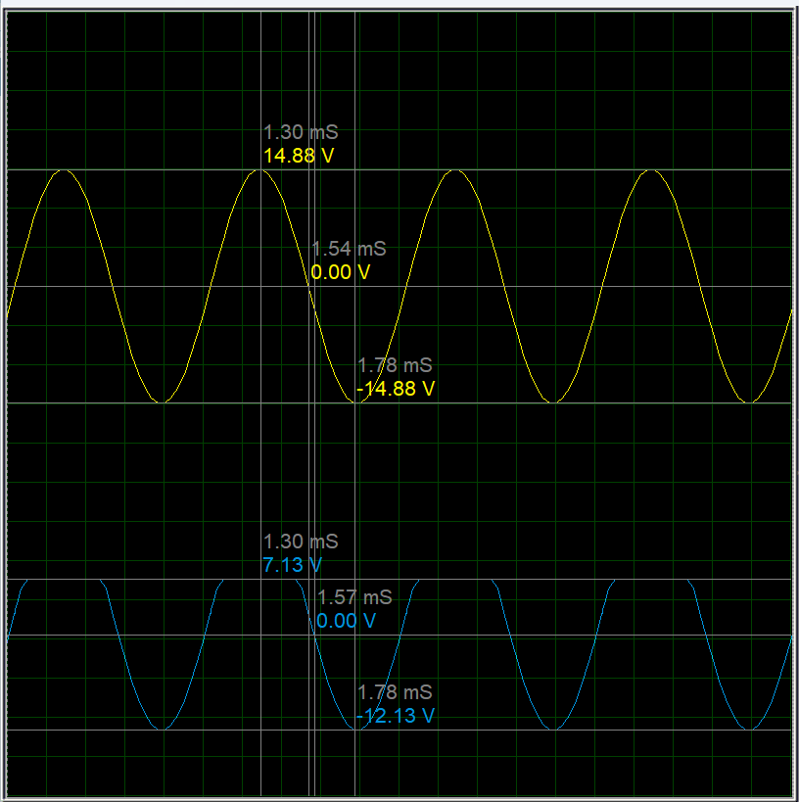

Figure 4: Input and output Signal

# Discussion:

Here,

For positive half cycle,

Vinput < Vbias : Voutput = Vinput - Vbias

Vinput > Vbias : Voutput = 0 V

Here, Vbias = 5 V

|  |  |
| --- | --- |
| **Vinput** (in volt) | **Voutput** (in volt) |
| 15 | 0 |
| 0 | -5 |

Again,

For negative half cycle,

Voutput = - Vinput - Vbias

Here, the numbers don’t exactly match the digits in the simulation due to voltage drop accross the diode as it is not an ideal diod